Cloud Infrastructure and Services
25CS2206E
2026-2027 Even Trimester (T5)
SKILL 1:
Create an IAM user with programmatic access only, generate and download the Access Key ID and Secret Access Key, and configure an AWS billing alert to receive an email notification when the Free Tier usage approaches or exceeds the specified limit.
IAM User Creation, Access Key Generation and AWS Billing Alert Configuration

Prerequisites
- Active AWS account.
- Access to the AWS Management Console using the root user or an account with administrative permissions.
- Valid email ID for receiving billing notifications.

Part A: Create an IAM User with Programmatic Access Only
- Log in to the AWS Management Console using your root account credentials.
- In the search bar at the top of the AWS Console, search for IAM and select Identity and Access Management (IAM).
- From the left navigation panel, select Users.
- Click Create user.
- Enter a suitable username (e.g., Student-IAM-User).
- Do not enable AWS Management Console access, as the user requires programmatic access only.
- Click Next.
- Under Set permissions, select Attach policies directly.
- Select the required permissions policy based on the tasks to be performed. For example, select Administrative access based on the tasks.
- Click Next and review the configuration.
- Click Create user to complete the process.
- Verify that the newly created IAM user appears in the Users list.
Screenshot 1: IAM user created successfully; console access is shown as disabled.
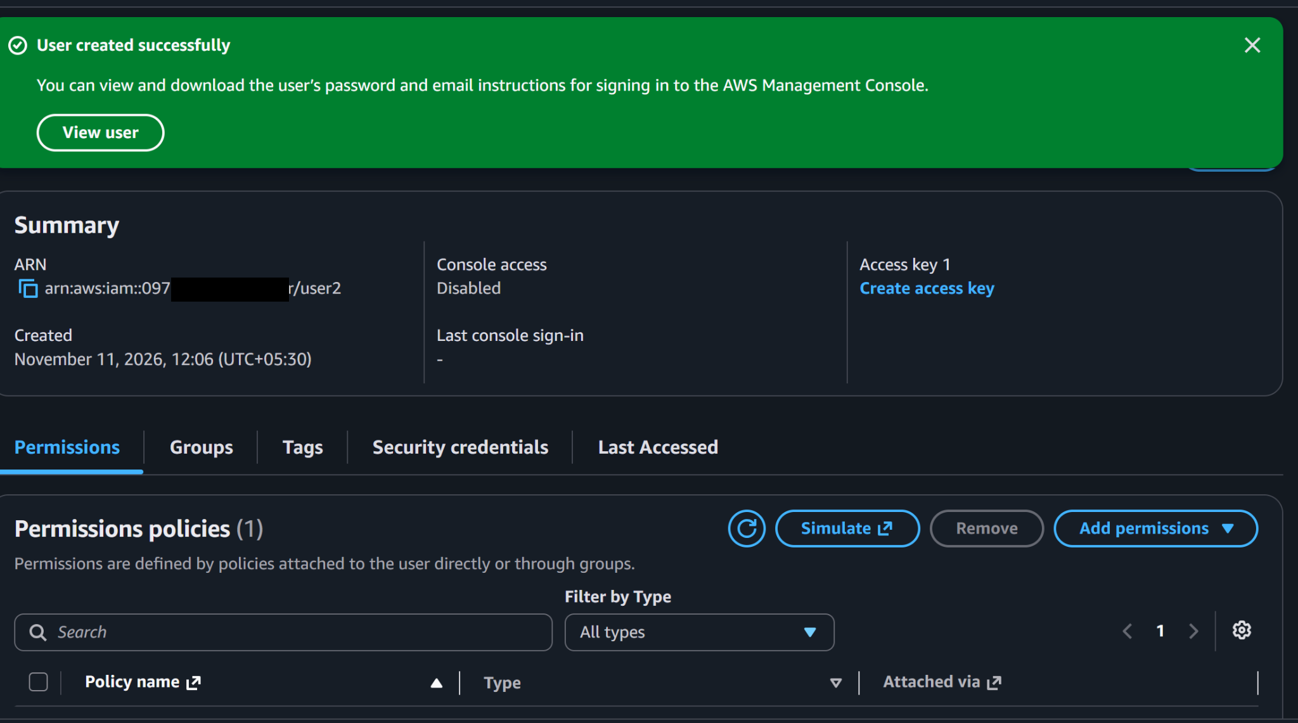
Screenshot 3: Additional IAM password screen. Note: this screen shows a console password enabled, which differs from the programmatic-access-only setting described in Part A.
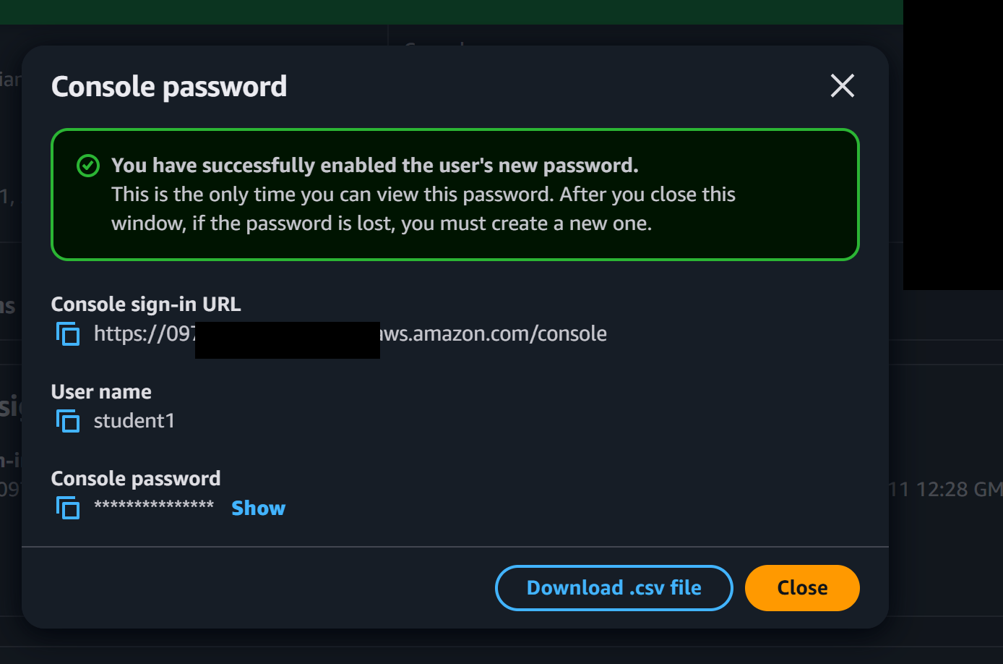

Part B: Generate and Download Access Keys
- In the IAM dashboard, select the newly created IAM user.
- Open the Security credentials tab.
- Scroll down to the Access keys section.
- Click Create access key.
- Select the appropriate use case, such as Command Line Interface (CLI), if the key is intended for AWS CLI access.
- Acknowledge the recommendation and click Next.
- Optionally enter a description tag (e.g., Student-CLI-Access-Key).
- Click Create access key.
- The console displays the following credentials:
  - Access Key ID
  - Secret Access Key
- Click Download .csv file to download the credentials securely.
- Verify that the downloaded CSV file contains both the Access Key ID and Secret Access Key.
- Click Done.
Screenshot 2: Access key retrieval page. The visible access key ID has been masked for security.
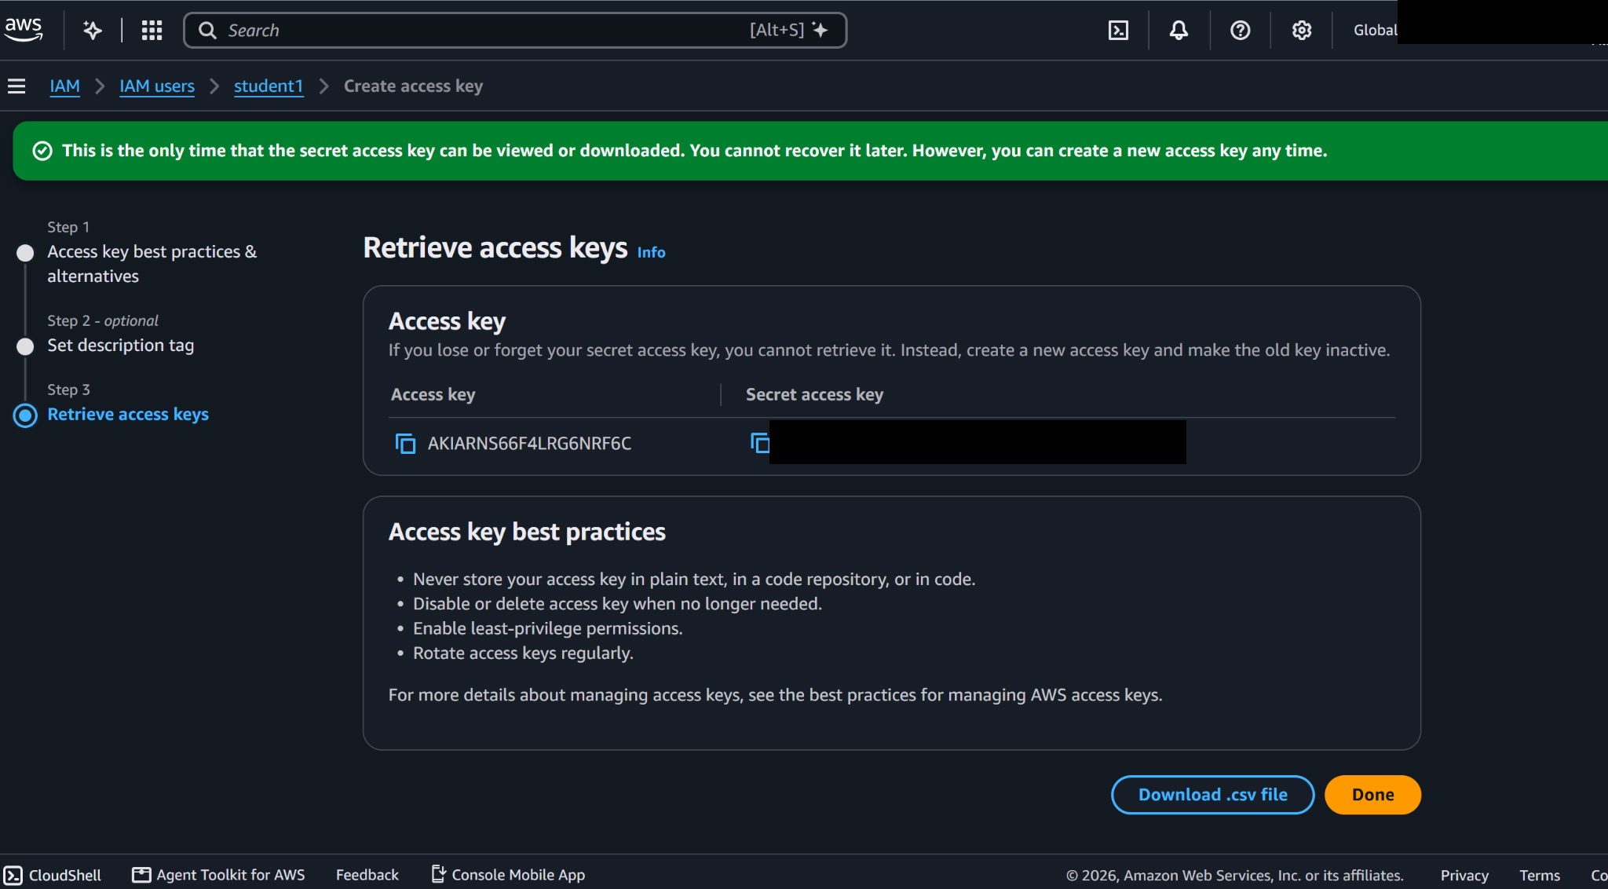

Part C: Configure AWS Free Tier Usage Alerts
Configure alerts through Billing Preferences.
- Log in to the AWS Management Console using the Root User account.
- Search for Billing and Cost Management in the AWS search bar and open it.
- In the left navigation panel, locate Preferences and select Billing preferences.
- Locate the Alert preferences section.
- Click Edit.
- Select the checkbox Receive AWS Free Tier usage alerts.
- Under Additional email address to receive alerts, enter the email address where notifications should be received (if required).
- Click Update to save the settings.
- Verify that the Free Tier usage alert option is enabled.
Part D: Configure AWS Billing Alerts Using the Custom Budget Option
- Log in to the AWS Management Console using the root account.
- Search for Billing and Cost Management and open it.
- From the left navigation panel, select Budgets under Budgets and Planning.
- Click Create budget.
- Under Budget setup, select Use a template (simplified) which is set by default, In Templates – new select Zero spend budget (Create a budget that notifies you once your spending exceeds $0.01) which is set by default and then give the budget name and email id and goto step 17.
or Customize (advanced) instead of using a template.
- Under Budget types, select Cost budget.
- Click Next.
- Configure Budget Details
- Enter the following details:
Field | Value
Budget name | AWS-Monthly-Cost-Budget
Period | Monthly
Budget renewal type | Recurring budget
Start month | Current month
Budgeting method | Fixed
Budgeted amount | $0 (example)
Budget scope | All AWS services

10. Keep the advanced settings at their default values unless specific requirements exist.
11. Click Next.
Configure Alert Thresholds
12. Under Configure alerts, click Add an alert threshold.
Configure the alert as follows:
Field | Value
Threshold | 0
Threshold type | % of budgeted amount
Alert trigger | Actual
Email recipients | Your registered email address

13. Click Next after configuring the alert thresholds.
14. On the Attach actions page, skip the optional budget actions for this experiment.
15. Click Next.
16. Review all the configured budget details and alert thresholds.
17. Click Create budget.
18. Verify that the newly created budget appears in the AWS Budgets dashboard.
19. Check your email for AWS budget notifications when the configured thresholds are reached. Verify your email address if AWS requests confirmation.
Screenshot 4: AWS Zero-Spend Budget creation confirmation and budget details.
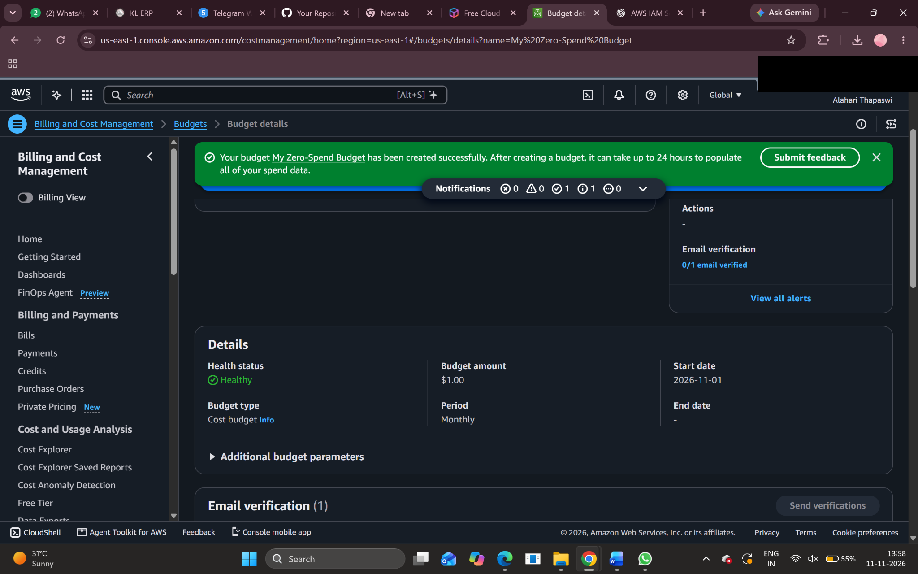
Screenshot 5: AWS Billing credits summary showing active credits.
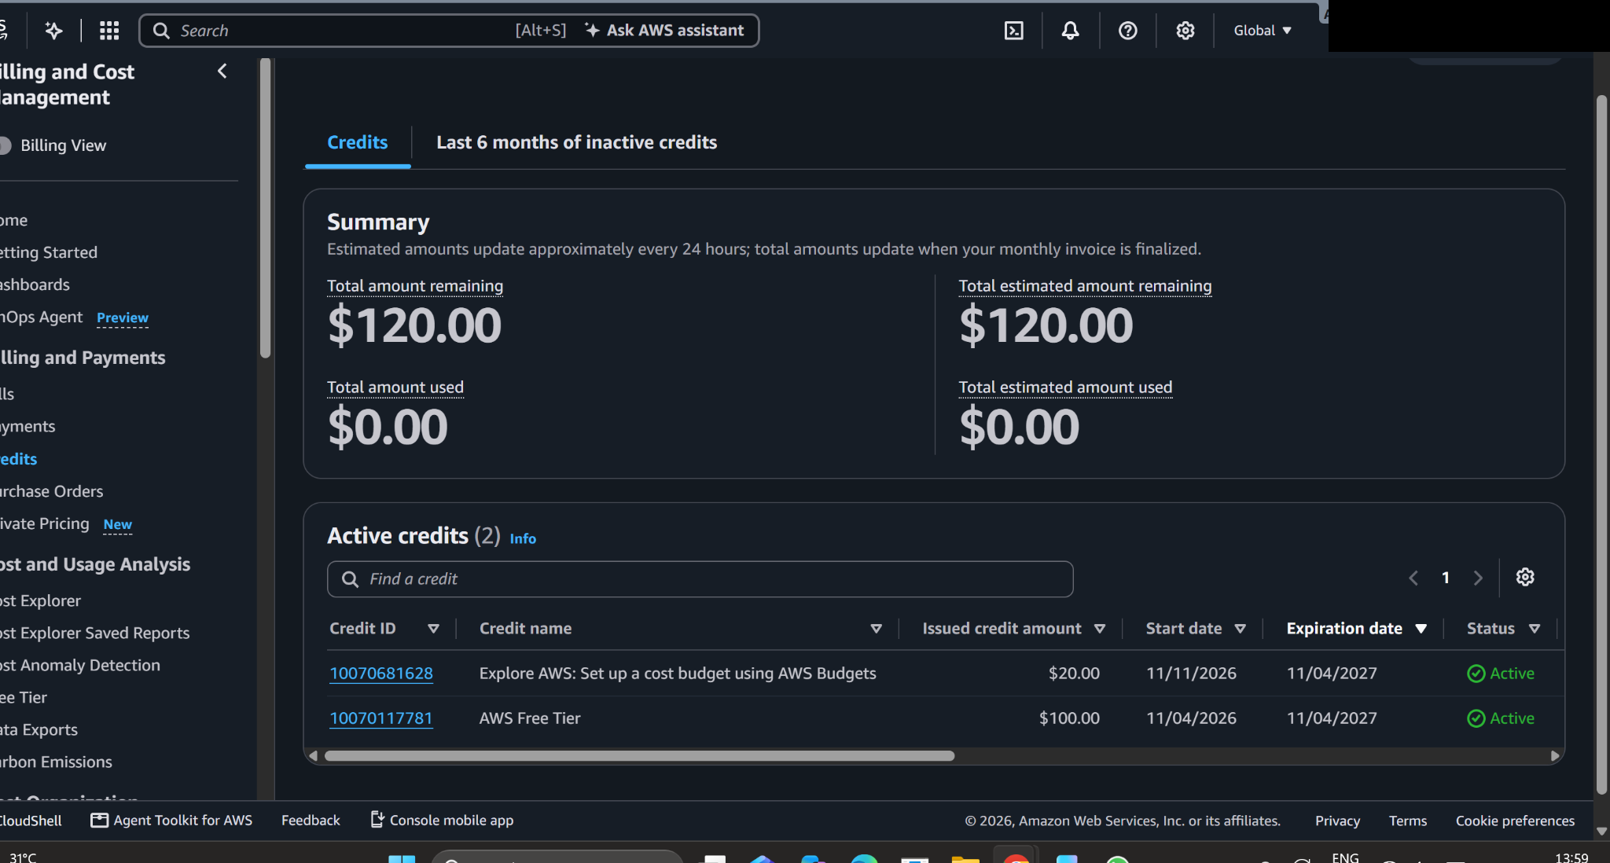

Expected Outcome
After completing this experiment, students should be able to:
- Successfully create an IAM user without console access.
- Generate and download programmatic access credentials.
- Understand the importance of securely managing AWS access keys.
- Enable AWS Free Tier usage notifications.
- Create a monthly AWS Budget with email alerts.
- Monitor AWS resource usage and control unexpected expenses.

